User manual

Home alarm system

Ekaterina Kurysheva

Prague 2018

Installation

What you need
For installing and running home alarm system Safe Home, you need the following hardware components.
- Raspberry Pi model B or newer compatible with model B.
- A micro-USB cable.
- An SD card with at least 8GB capacity.
- A MIFARE RFID-RC522 card reader.
- A PIR motion sensor.
- A USB camera.
- A LED.
- A 330-ohm resistor.
- A breadboard and Male-Female jumper wires.
- An Ethernet cable.
- A personal computer with Tomcat server and an Oracle database.
- An Android mobile device with API from 19 up to 27.

Set up your Raspberry Pi
- Follow the instructions from the official website https://www.raspberrypi.org to install the Raspbian operating system. Boot the computer.
- Open the SD card with installed Raspbian on your personal computer and create an empty file named SSH to connect to the computer via SSH connection later. Insert the SD card back to Raspberry Pi, connect to your local network with the Ethernet cable and boot it. Connect to your Raspberry Pi via SSH with pi as a username and raspberry as a password.
- Update the software on the Raspberry Pi computer by running the following commands:
sudo apt-get update -y
sudo apt-get dist-upgrade -y
- Set up time, expand file system and enable SPI interface in configurations menu after running the command:
sudo raspi-config
- Shutdown Raspberry Pi and connect the remaining hardware components following the scheme from Figure 1. Boot it again and connect via SSH.
- Copy folder Installation to the /home/pi/ directory. Run the following commands:
cd Installation
chmod +x install.sh
./install.sh
- When the script has finished, make a cold reboot to your Raspberry Pi. Within a couple of minutes, the LED will blink three times. This will mean that installation finished correctly and the security module is ready to work.

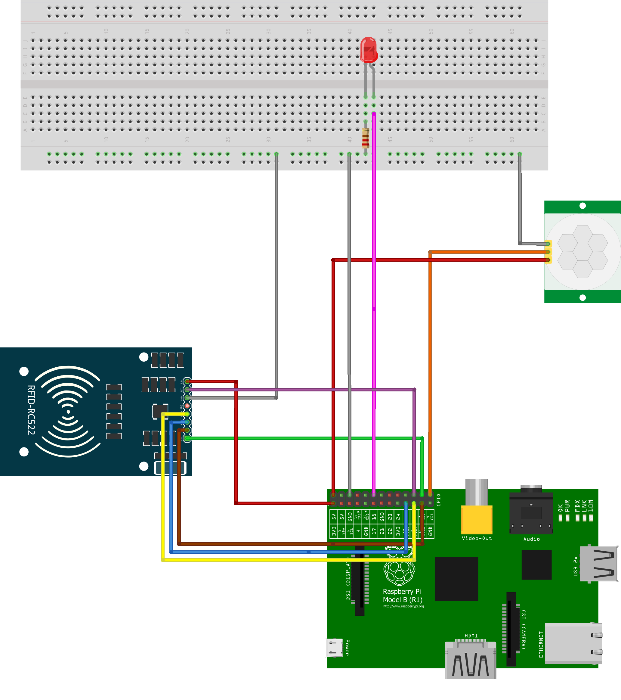
Figure 1. Raspberry Pi circuit scheme.

Set up your server
Follow these instructions on a computer with an Oracle database and Tomcat server. In your Oracle database create a user safehome as following:
create user safehome identified by safehome;
grant CREATE SESSION, ALTER SESSION, CREATE DATABASE LINK, CREATE MATERIALIZED VIEW, CREATE PROCEDURE, CREATE PUBLIC SYNONYM, CREATE ROLE, CREATE SEQUENCE, CREATE SYNONYM, CREATE TABLE, CREATE TRIGGER, CREATE TYPE, CREATE VIEW, UNLIMITED TABLESPACE to safehome;
- Connect to the database as a safehome user and run the create_schema.sql and insert_data.sql scripts.
- Deploy SafeHome.war on your Tomcat server.
- Find out the address of the computer, where your server runs, reachable from the Internet.
- On your Raspberry Pi, in the file /home/pi/Installation/dist/config.json set the “server” variable’s hostname and port number according to your actual server’s address.

Android application
Install the app-debug.apk on your Android smartphone. The application is ready for usage.

Start using Safe Home
After you have successfully installed all the components, and LED connected to your Raspberry Pi blinks three times, after you connect it to the power supply, it is time to register the users of the system.

Register the users
- Find out the IP address of your Raspberry Pi by running the command on the terminal or via your network manager.
/sbin/ifconfig
- In a browser open page http://raspberryip:8080/RpiServer, where raspberryip is the IP address you found out. On the welcome page of the web application login with username admin and password admin as in Figure2.
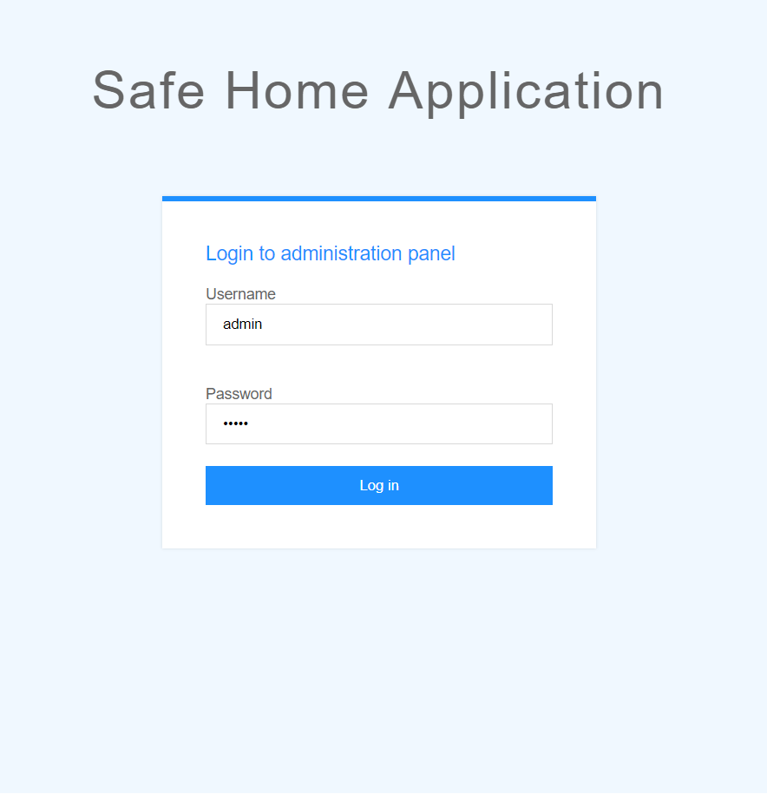
Figure 2. Login page
- Follow to Add new user section from the Figure 3. You will see the message asking you to put the token to the reader. After the LED blinks once, put your token to the reader and after about five seconds press the Add new user button again.
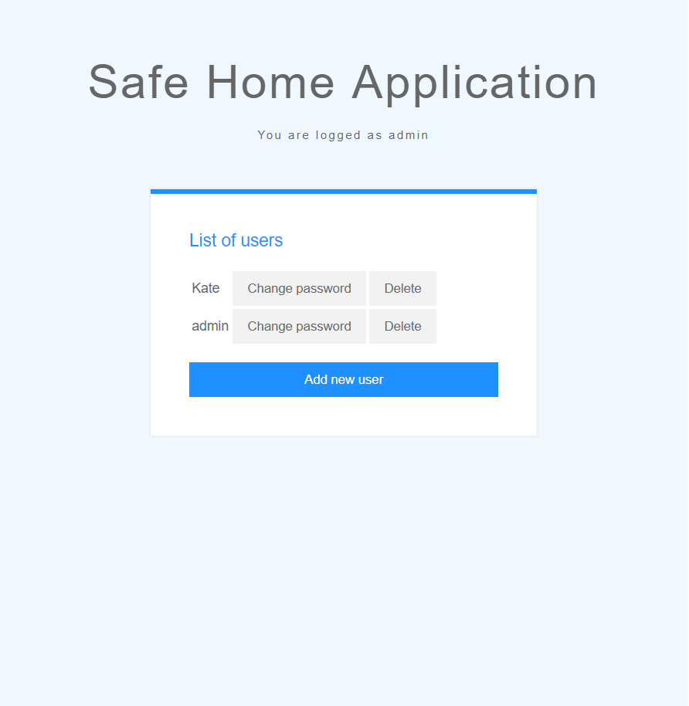
Figure 3. User list page
- Fill the credentials for the user as on Figure 4. You will need these credentials to login into the Android application. You can register as many tokens, as needed, following the same instructions.
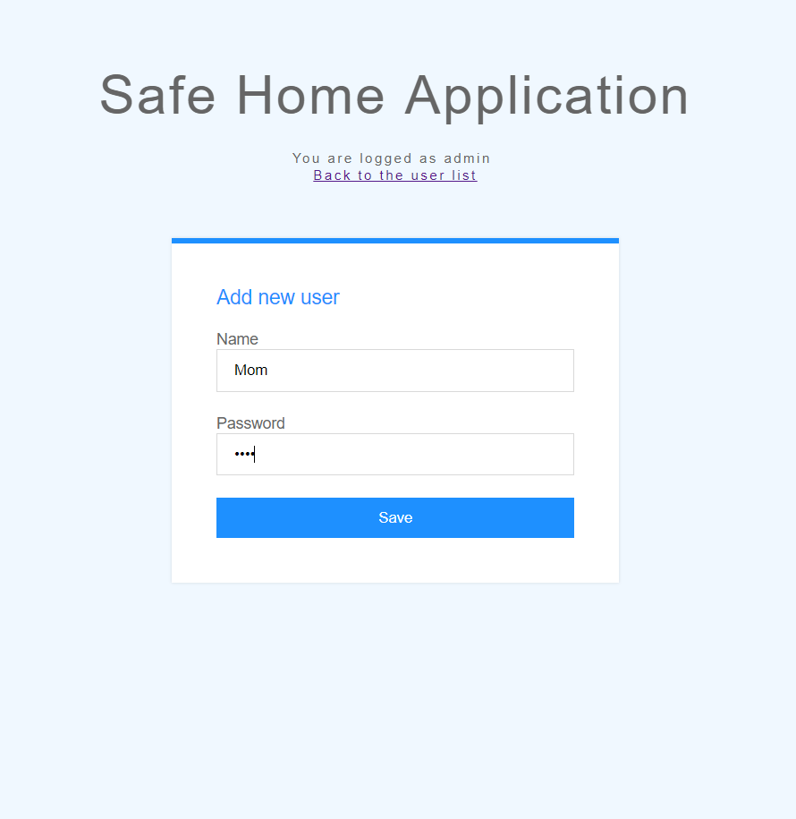
Figure 4. New user registration
After you created the users, you can delete them or change their passwords. You cannot register the same RFID token to different users at the same time. To register the token for a different user, delete the current user of the token and register the new one with the token.
Test whether the registration was successfully finished. Put the registered token to the reader and wait if the LED will blink two times. If it blinks, the token was recognised and the system was activated. After at least ten seconds you can turn the system off with the token. The LED will blink once for a long period when the system turns off. If the test fails, try the registration process again.

Set up the application
Now the registered users can log in to the Android application. If your server is not available from the Internet, your mobile device must be connected to the same network as your server.
- Enter the hostname and port number of the server during your first login.
- Use the credentials you set up in the web application to log in.
- Give the application permission to use the external storage. The application needs this permission to save the pictures on your device.
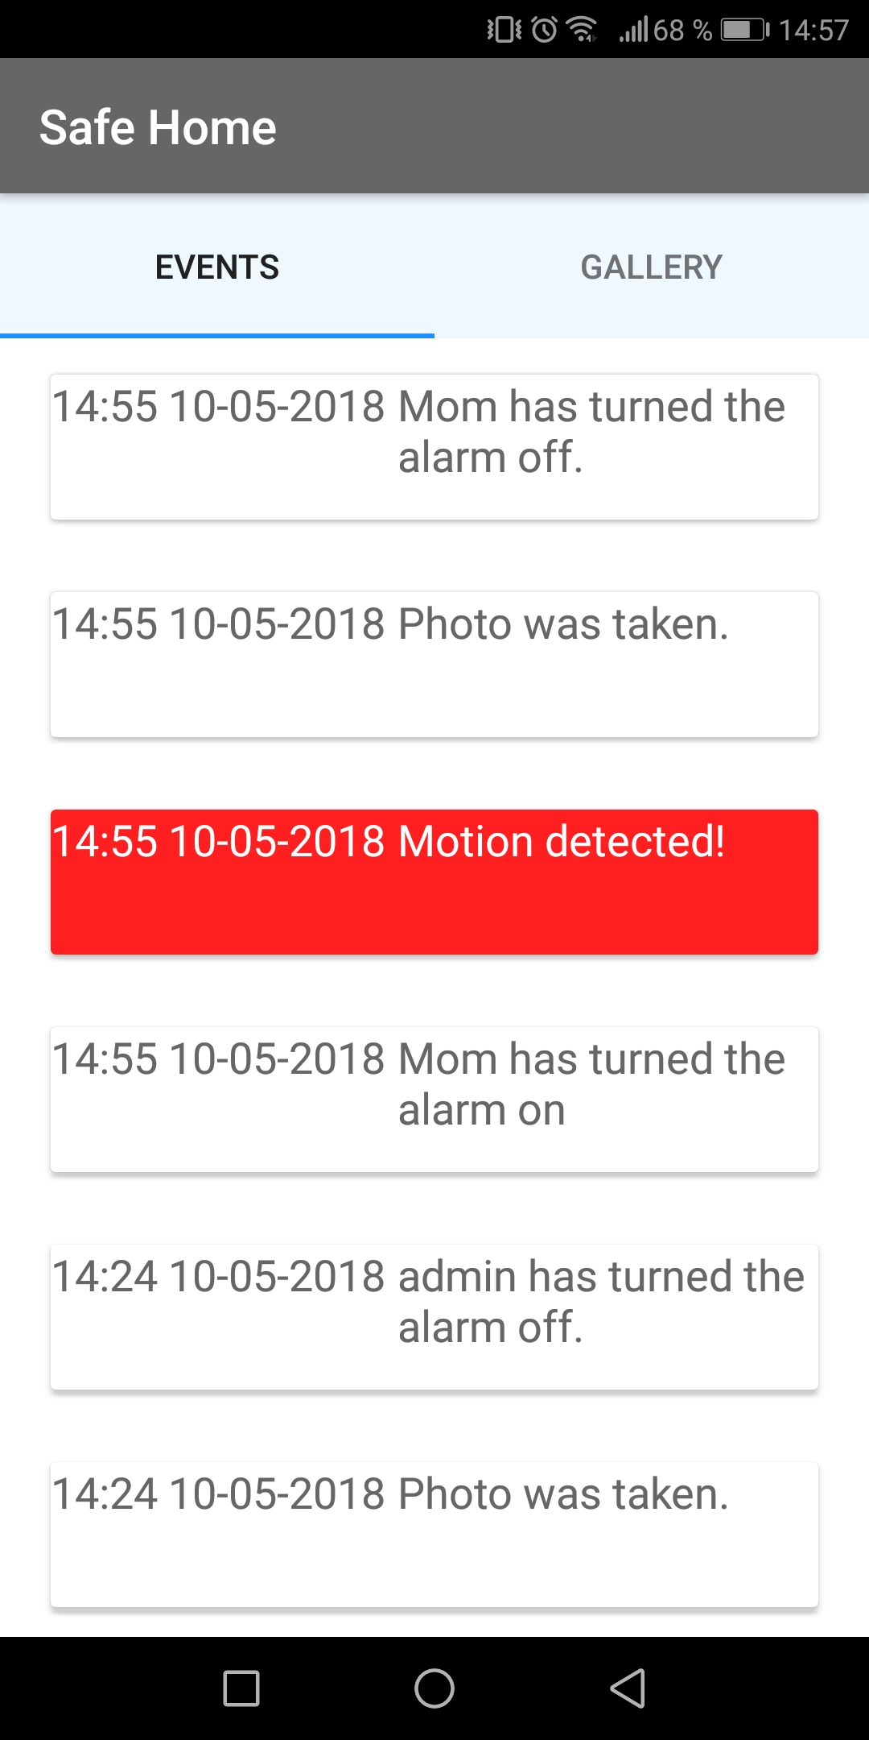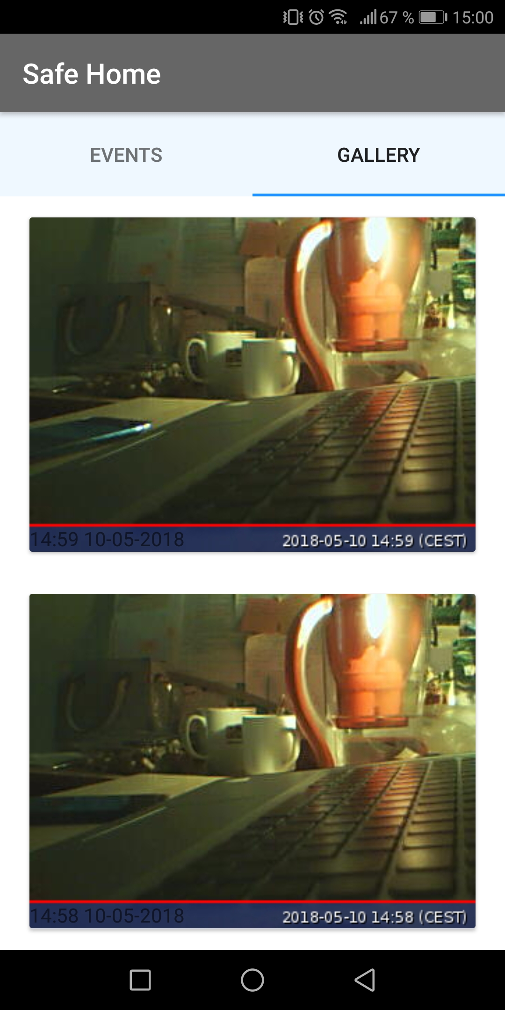
Figure 5. The Android Application interface
Test the application by turning your system on. The application will load new events. Move around the motion sensor. The notification must appear within two minutes depending on the Internet connection and on the device battery optimization settings. The pictures must be loaded shortly after the notification. If the test fails, check whether the application did not log you off, in this case, perform the logging in again and check the device’s cache policy. Try turning off optimisation of the application in the device settings menu.

